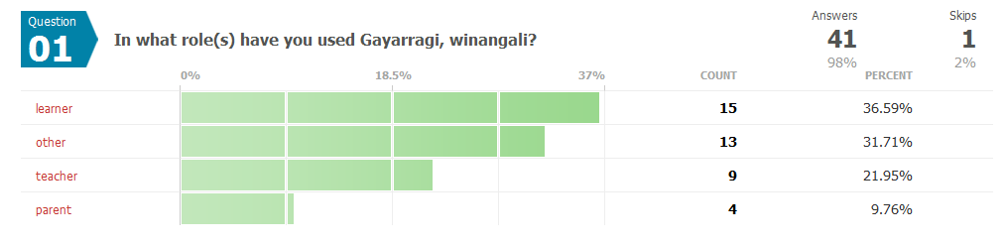Question 01
In what role(s) have you used Gayarragi, winangali?
Answers 41 98%
Skips 1 2%

learner 15 37%
other 13 32%
teacher 9 22%

If "teacher", please indicate the number of students; if "other", please describe:

- Learner and teacher. Used with the class for only one term.
- as a student support officer with secondary Aboriginal & TSI students in boarding schools and on scholarships
- 30
- Interested friend of Uni student
- I am trying to learn our language
- Initially six Aboriginal and Torres Strait Islander students. With the expertise of the school's music specialist all students (i.e.350) learnt and performed a song from Gayarragi, winangali at a whole school Assembly.
- The Dictionary have been extremely useful for building on Aboriginal Pedagogies in Schools in that Counrty...Yuwalaraay and Gamilaraay Schools ( Goodooga and Walgett), have used Language to inspire their ways of teaching through Culture. The resource is fantastic.
- Im not from that Country, however, I have a srong link through my Mob... Melinda Gibbs and Rhonda Ashby have transformed their ways of knowing and teaching using Language as a guide for best practice.
- i am a group facilitator in the mental health field, and i work in Indigenous communities
- interested researcher
- 55
- I'm a journalist who wrote about it.
- Personal reference
- I wanted to learn my lingo, I speak Darug dalang, and I am also Gamilaroi man, working in Pilbara with Yindjibarndi, so it has become a need, to learn my grandmothers language..
- I am trying to learn so that I can eventually teach
- 13
- 31
- AIATSIS staff member. This is a resource recommended to clients.
- 200 university students
- The students were spread over two classes HRLM at Singleton (Cert 1 TAFE and Gathang/Warami at Williamtown (Cert 1&2), about 24 students in all. We accessed many neighbouring languages for comparisons
- 8-10 per year in Master of Indigenous Languages Education unit Technology and Language Teaching. Hi guys! :)
- I am learning to pass the knowledge on to my children.
- I am a special needs support teacher so I wanted to support a child who had moved to the coast in her language
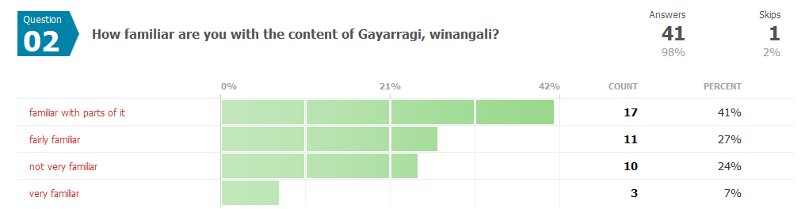Question 02
How familiar are you with the content of Gayarragi, winangali?
Answers 41 98%
Skips 1 2%

familiar with parts of it 17 41.46%
fairly familiar 11 26.83%
not very familiar 10 24.39%
very familiar 3 7.32%

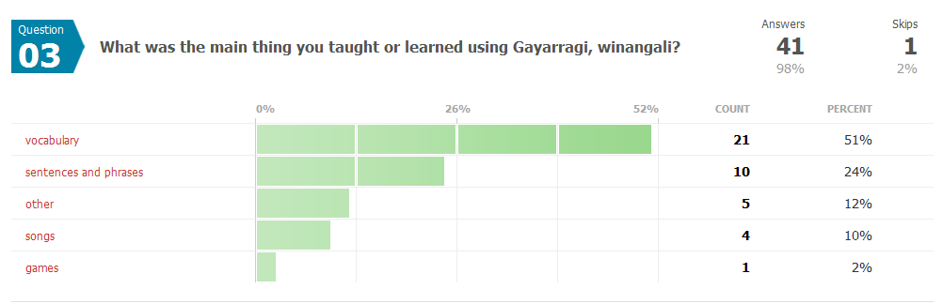Question 03
What was the main thing you taught or learned using Gayarragi, winangali?
Answers 41 98%
Skips 1 2%

vocabulary 21 51.22%
sentences and phrases 10 24.39%
other 5 12.2%
songs 4 9.76%
games 1 2.44%

If "other", please describe: Comments 7

- Pleasure in the printed dictionary
- Structure of teaching learning approach
- pronunciation
- what a multimedia product can look like
- songs were also a fun way of interacting
- Application of ICT in languages education.
- intonation, word order

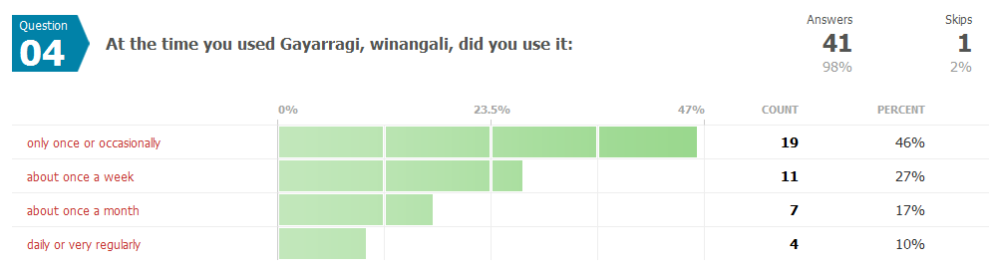Question 04
At the time you used Gayarragi, winangali, did you use it:
Answers 41 98%
Skips 1 2%

only once or occasionally 19 46.34%
about once a week 11 26.83%
about once a month 7 17.07%
daily or very regularly 4 9.76%

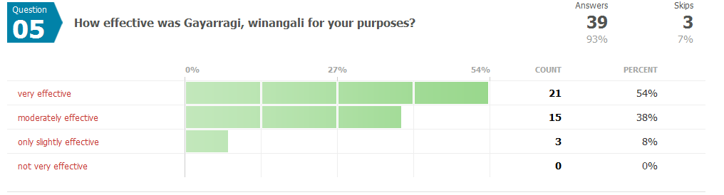Question 05
How effective was Gayarragi, winangali for your purposes?
Answers 39 93%
Skips 3 7%

very effective 21 53.85%
moderately effective 15 38.46%
only slightly effective 3 7.69%
not very effective 0 0%

Please tell us more about its usefulness or limitations
Comments 23
- more vocalisations of pronunciations would be great
- not applicable
- I have had strokes and find it difficult honey not anything to do with the program
- Needs to be culturally based in living culture not academic linguistics, cultural concepts and theoretal approach, otherwise there will be no progress in language revival without cultural location within the world view of the people.
- Useful in finding sentences that demonstrate the use of different types of words.
- It's a fantastic resource that is superior to what is currently available online for Kamilaroi language earners.
- Im from Ngemba Country, to me it is the most wonderful Language Resource, our resources are very limited in our area. It is truly dynamic... This great resource is exactly what our Language group needs.
- Yaama, I believe it is very well set out, but more audio examples would be helpful with correct pronunciations.
- great multimedia linking text and sound -- it's a shame that lots of the recordings are by a whitefella
- I did not spend much time with it at the time, due to other commitments, hence I am unable to answer this question.
- would like to see more interactive activities, use the language in everyday living,
convert english to gamilaraay by typing in sentences, develop more stories about landscapes, sky, rivers
- I had problems with the download but that was mainly an issue with my computer.
- I'm really looking forward to interacting with Gayarragi, winagali over coming months. As a auditory modality learner any sound files of the spoken language optimises learning for me. My initial reaction is that the efforts to include songs and everyday phrases makes this a great program I will want to interact with in learning language.
- I found it very useful, I think you should look at Wanga maya and work within that kind of framework if you aren't already. I work for Juluwarlu, assisting with recording language, culture and ngurra and record it for archiving and future generations of Yindjibarndi
- Only that I couldnt get any two way communication. It is a really good program otherwise.
- useful to show a possible interface; to show incorporation of different media and forms (games).
- few visual data incorporated
- It is an excellent resource to recommend to Gamilaraay and Yuwaalaraay clients who approach the AIATSIS Audiovisual Archive.
- I am introducing Gayarragi as one method of language revitalization. This is very useful and effective for my purpose because students are interested and stimulated by the sound and visual.
- I used Gayarragi, winangali in the context of looking at other Aboriginal languages
- A good illustration of current best practice and a source of inspiration for students' own ICT projects.
- very useful and interactive
- Song reaches the heart of all children
- I used it with uni students; they found the speed of the speech made it difficult for them to understand it;

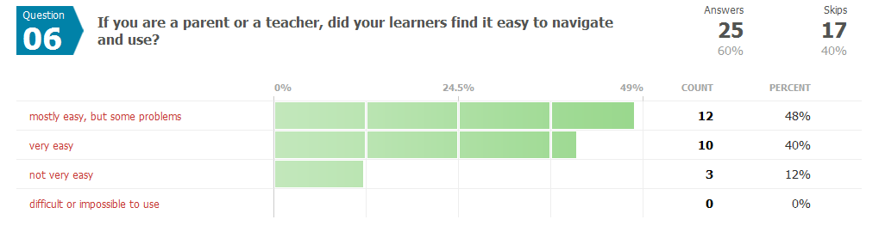Question 06
If you are a parent or a teacher, did your learners find it easy to navigate and use?
Answers 25 60%
Skips 17 40%

mostly easy, but some problems 12 48%
very easy 10 40%
not very easy 3 12%
difficult or impossible to use 0 0%

Please add any further feedback about ease or difficulty of using Gayarragi, winangali:
Comments 8

- not aplicble
- Software played up could be my pc or the sites
- As a teacher, I found it very useful to use and read. The difficulty is I am not a linguist or from that Country, I stuggle with the pronounciation of words.
- N/A
- Speaking and singing is how we communicate, translations in dialogue of common speech and also songs about ngurra and Law
- of course, we did not use the material to learn GW, but to learn more about multimedia products made for a specific community
- Not everyone reads the instructions or applies good sense.
- being able to access multiple sentences by number is great; ditto the 'go back' ; some problems about when to include a dash when searching

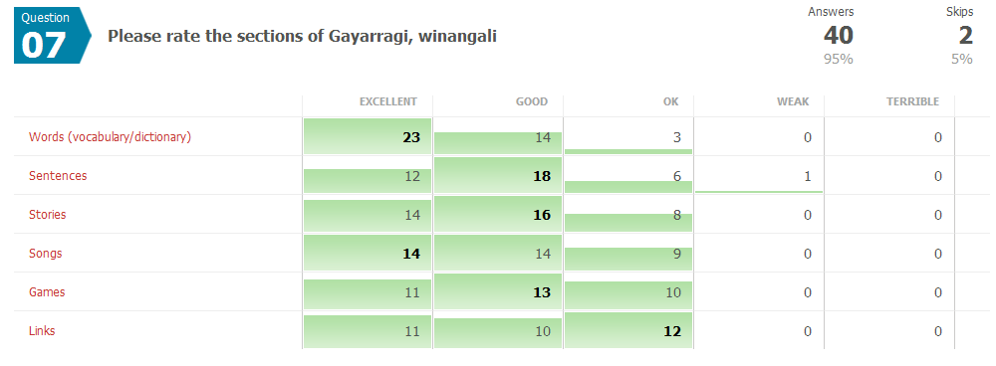Question 07
Please rate the sections of Gayarragi, winangali
Answers 40 95%
Skips 2 5%
 | Excellent | Good | OK | Weak | Terrible
Words (vocabulary/dictionary) | 23 | 14 | 3 | 0 | 0
Sentences | 12 | 18 | 6 | 1 | 0
Stories | 14 | 16 | 8 | 0 | 0
Songs | 14 | 14 | 9 | 0 | 0
Games | 11 | 13 | 10 | 0 | 0
Links | 11 | 10 | 12 | 0 | 0

Question 08
Please use this box to make any further comments and suggestions, or to note any problems or errors you encountered:
Answers 21 50%
Skips 21 50%

- My main problem was that I could not download onto my Apple computer. I had to find another computer to use.
- more modern day sentences would be good. Even a section on how to do an acknowledgement of country.
- Although there were some issues i encountered, and i did not use G,w as much and frequently as i would have liked, i have only good evaluations for your resource. I think it is wonderful that you are also taking the time to consult users to conduct this evaluation so that you can continue to improve and further increase the possible learning outcomes for all users. Great stuff!! Thankyou for this resource to help me learn this wonderful language of my Ancestors. Keep up the wonderful work!! Ps. If you need help with the 2nd edition, i am currently studying MILE (Master of Indigenous Languages Education) with the Koori Centre at Sydney Uni. I would be glad to help and would actually appreciate the opportunity to be involved. Thanks again.
- It is very good to see the language alive and in use.
- I had problems but that was me not the program
- The language needs to be based in appropriate cultural context, language is a lived thing. Its difficult to do but there are international indigenous examples out there.
- The thoeretical position needs to shift to be progressive otherwise your 'beating a dead horse' people can learn things but their speeech will be intelligable to a real speaker, not that there is any left apart from Ian Sim and maybe some older people hiding around the place.
- But if the aim is to recreate a language and design something new thats great, there are great examples of that, just refer to Tolkien and have fun speaking elvish or even star trek and speak klingon.
- Otherwise step backwards and get the cultural foundation, something many linguistists aren't too good at but good work for trying and in the absence of existing work, all good and thank you.
- Some of the gloss translations were confusing. Some more clarification of some suffixes required but overall an excellent resource.
- This is a fantastic, practical resource that is ready to use in a classroom setting. The only feature which I would like to see enhanced is it would be fantastic if the dreaming stories could be made into animations. There is a very limited number of animated Aboriginal stories online. The Australian Museum site had a great selection of animated dreaming stories from various Australian states but these have been withdrawn.
- Perhaps this could be a High School or TAFE project for Gamilaraay/Yamilaraay media students? PaCE Funding may be available for this type of project?
- Thank you David and John, truly inspiring stuff!
- I have been working in the Pilbara,WA and was most impressed by the set up at Wanga Waya language centre. I think the Gayarragi, winangali is very good and hope it continues to develop and improve where possible. I am a strong supporter of promoting all ngarda languages
- Would love to actually attend proper classes to learn more
- Thank you for your work and having created this resource.
- The other Indigenous educators I interviewed all said this was the yardstick.
- The colour sometimes made it difficult to read.
- Yaama, wanthiwa, waaiba, warami great work so far, the Ancestors would be proud. My only suggestion, is to keep working with it until there is nothing you could add. Maybe more interactive language items, and possibly some video and more audio.
- because I only have apple Mac the program did not run very well. I was able to use another program to run it on my Mac. So it would be great to see a mac friendly version in the future. However, I am aware this can often be time consuming.
- I was a bit disappointed at the lack of attribution. I would like to know who is speaking the various sentences, when and where they were recorded, where the original recordings can be found and whether transcripts are available. It would also be a good idea to say permission was obtained from XXXX to use these recordings in this product.
- Also, the inclusion of field notes etc is a bit troublesome. Austin's transcripts of the Wurm fieldnotes are on restricted access at the AIATSIS Library. If you have permission to use these you should explicitly state this. Not doing so creates problems for AIATSIS as we can't give people access without asking permission according to the conditions of access put in place by Austin.
- I would also like to hear more Gamilaraay and Yuwaalaraay people speaking (particularly in the 'stories' section)
- The Dhirranbaya song is awesomely cute!
- No problems really, our use was not extensive, however, it did spark a lot of ideas and the desire to see something similar in the other languages. Thank you for this resource.The addition of some everyday dialogues would be good as would video, c.f. korero maori.
- The use of translated English songs that foster English stress are always a concern as are word games.
- A Mac friendly version would be good.
- the only thing that I would include is the interpretations of new words, like slang..
- On some [older?] PCs it comes up with error messages when launching; you need to know to click 'ignore' about 12 times

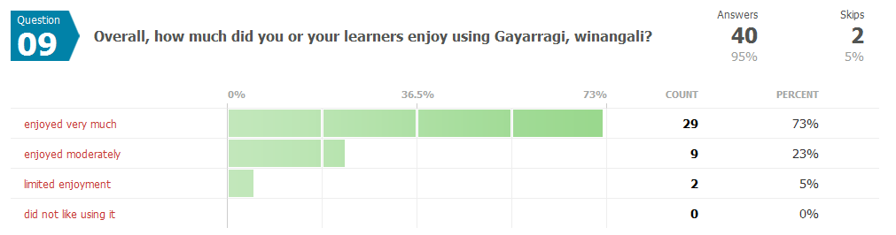Question 09
Overall, how much did you or your learners enjoy using Gayarragi, winangali?
Answers 40 95%
Skips 2 5%

enjoyed very much 29 72.5%
enjoyed moderately 9 22.5%
limited enjoyment 2 5%
did not like using it 0 0%

Please tell us how we can make using Gayarrai, winangali more enjoyable
Comments 13

- have more modern sentences available se we can transfer soundbytes to ipods, iphones etc so we can practice on the go.
- I cannot think of anything
- Explore other Indigenous examples, need a discussion for this
- Better games, see First Nations resources.
- More songs (another CD?) and songs with suggested actions or appropriate dance moves.
- WHEN I HAVE USED IT, i HAVE ENJOYED IT VERY MUCH.
- More audio examples or perhaps online video/audio language examples, perhaps an online/broadcast, video language program?
- I'm unable to tell at the moment, due to limited use...
- Involve our young ones more, to appoint where our language is our common tongue, at least on par with English dalang...
- more photo/video, if possible?
- It's a very nice product. More attribution and info on permissions and copyright is needed. It would be good if the story notes could be embedded into the application rather than been linked docs.
- more pictures, explaining their culture
- We will be using this more in the coming months we have been developing a program around this CD and will use it as a resource and learning tool over the coming months

Question 10
We are grateful for your feedback. If you would like to keep updated about Gayarragi, winangali, please enter your email address below:
Answers 29 69%
Skips 13 31%

eromalis@yalari.org
deniseann@live.com.au
thomas.degens@det.nsw.edu.au
joelamac@msn.com
youndalan@yahoo.com.au
murri_star@yahoo.com.au
allan.williams6@hotmail.com
lynn.price@ed.act.edu.au
robin.roberts3@tafensw.edu.au
melissa.kirby@det.nsw.edu.au
garryansell@hotmail.com
y.millard@centacarenenw.com.au
beckflick@gmail.com
ronpeeknl@yahoo.com
sharlene.deamer@det.nsw.edu.au
aaronswan1989@gmail.com
zanewhitehorn@gmail.com
paul.hodgkinson@theaark.org
Michael.ramalli@icc.gov.au
garryansell@hotmail.com
jacinta.hohnke@gmail.com
marcus.waters@griffith.edu.au
edward.mcguirk@det.nsw.edu.au
onnekosama@hotmail.com

Participant Locations
Participants by Country |  |  | Total Countries 6
 |  | Country |  | Total | Percent
 |  | Australia |  | 35 | 83%
 |  | United Kingdom |  | 2 | 5%
 |  | Japan |  | 2 | 5%
 |  | Unknown |  | 1 | 2%
 |  | Ethiopia |  | 1 | 2%
 |  | United States |  | 1 | 2%

